National Taiwan Normal University

Computer Robot Vision

Assignment 1
Magic Table

KEVIN 常凱文
11109356A

18 October 2025

Lecturer
Distinguished Professor Hansjoerg Jacky Baltes

- INTRODUCTION
The goal of this assignment was to demonstrate the ability to manipulate the frame of the video recorded with the camera. Especially in this assignment, we will manipulate the rectangular box that I hold with the ball surfs in the direction of rotation so that it looks like a magic trick when the rectangular box seems not to be moving, but the ball is still surfing. The main idea behind this magic trick is that I will detect the rectangular box to get the rotation angle, and after that, I will manipulate the received angles to make it remain stable by moving the video frame according to the rectangular box angles. There are so many methods out there to implement. Even Professor Jacky Baltes wrote in the assignment that we can implement it using feature points (SIFT, SURF, ORB), Edge Detection, etc. Still, in this report, I will only use Color Detection with Contour since I have tried all the methods written in the assignment, but unfortunately, none of them worked. So, let's start demonstrating “Magic Table with Contour Color Detection”.

- SYSTEM & COMPONENT
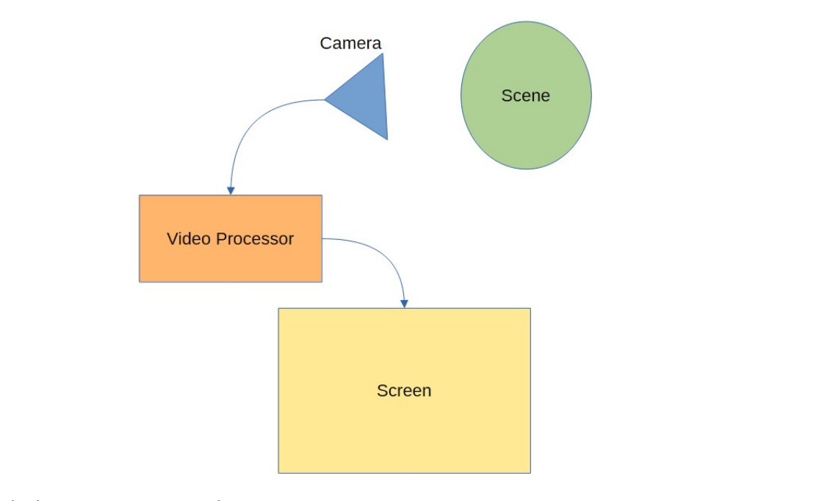
Picture by Professor Jacky Baltes

As I have mentioned above, “Manipulate”. This project is mostly related to Video Processing, which is the code written in Python. I used two of Python's famous libraries, called “OpenCV” for frame manipulation and “Numpy” for Numerical Initialization.
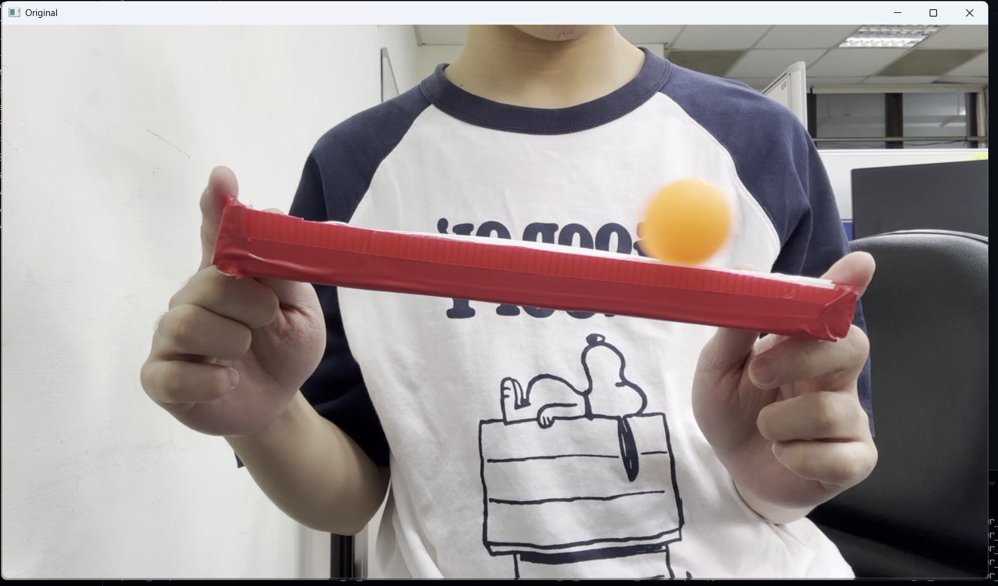
- Color Masking
The important point to note is that the color range, here, is the rectangular box with red color, so we just need to define the red color range in NumPy format and then mask the color so that only the red color is visible. By using a color space like HSV, I can set a range of acceptable hue values while being tolerant to variations in saturation and value. This prevents lighting changes from disrupting the color detection.
- Softening
After masking the red color, now there will always be noise, maybe like the color lightning, reflection, or movement is not stable, which could make the detection move everywhere. The solution is to utilize “morphology” to increase the size of objects in images as well as decrease them. We can also utilize morphology operations to close gaps between objects as well as open them (cv2.MORPH_CLOSE &
cv2.MORPH_OPEN). The last one we apply blur as a Smooth Transition.
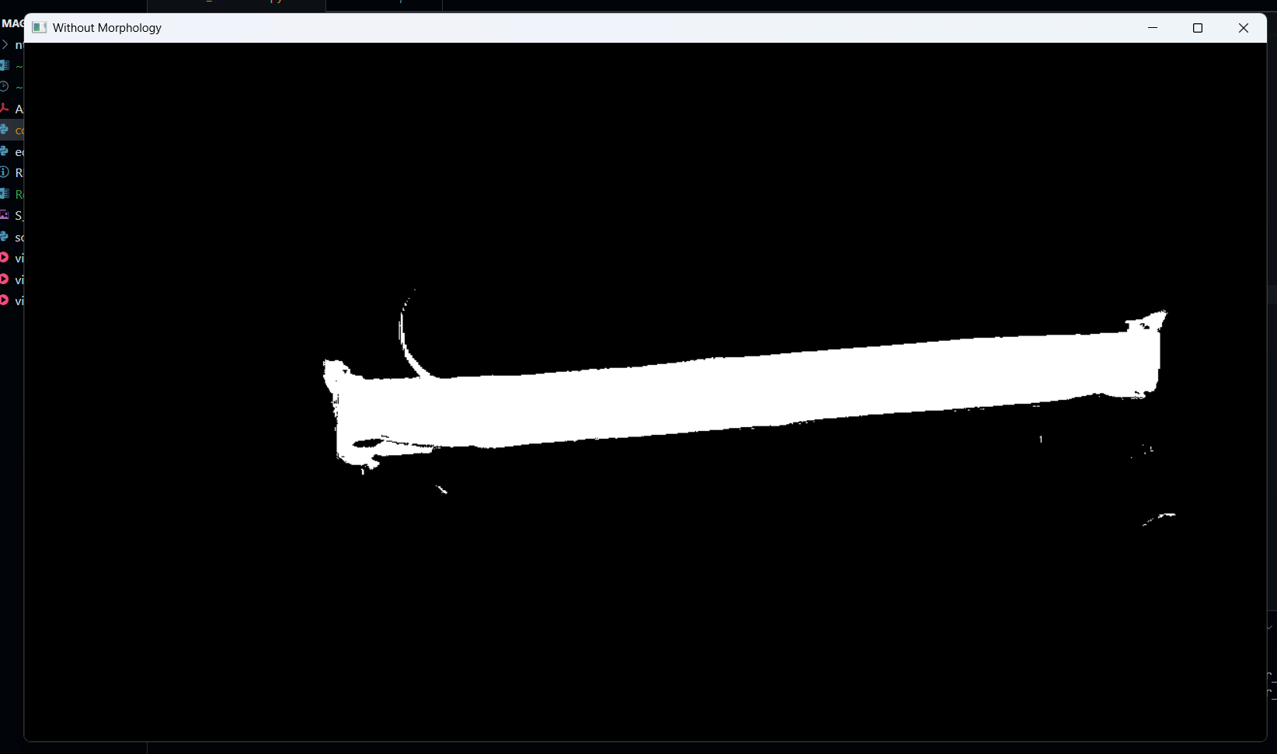
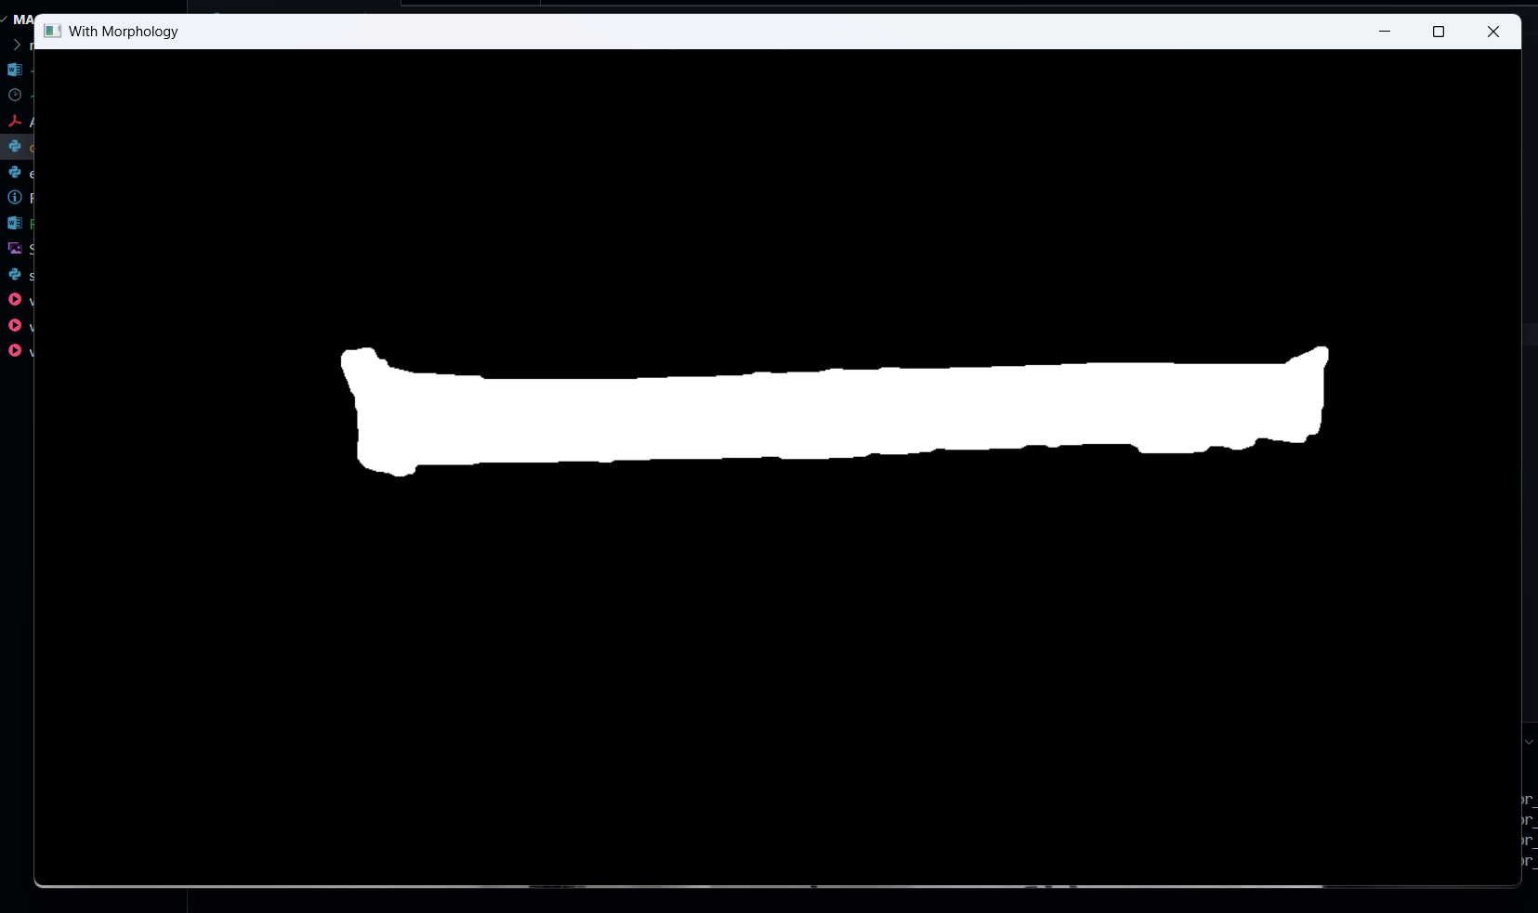
- Detection
After getting a good, low noise color masking, it is actually very easy to apply “Contour”, it will easily be detected because Contour is a robust method, and not only by color, but it does focuses on the geometry of an object.
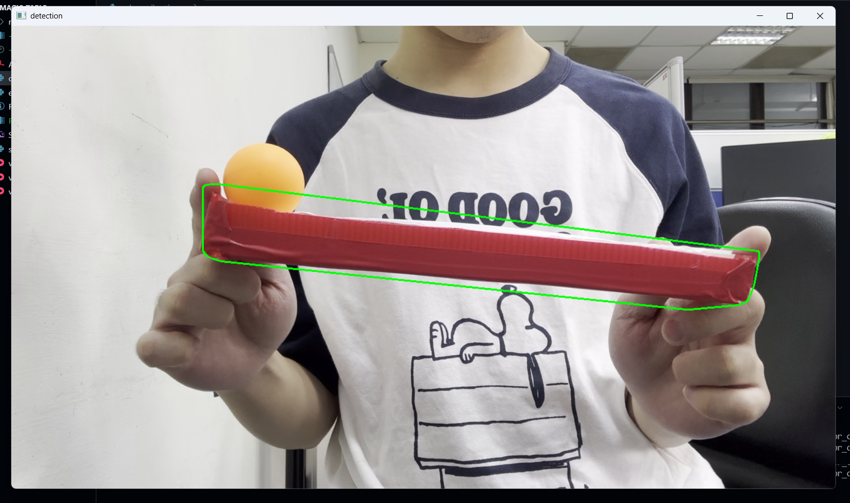
Now, because I got the detection already, it will also give the angle of rotation, and that’s what we need to rotate the frame according to the detected angle
- Angles
The idea is: Whatever the rotation of my rectangular box, I will always rotate my frame in the opposite direction. So, let's say my maze rotates left by -6°, then my frame should rotate right by 6° too. The implementation is: I have the center of my rectangular box from Contour detection, cv2.getRotationMatrix2D(center, maze_angle, 1.0) will return a 2x3 matrix M of the form:

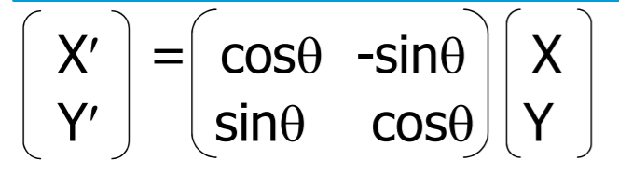
Picture by Stack Overflow
So with this matrix rotation, and the rotation around the given center rather than around the origin of the frame in normal scale (1.0). cv2.warpAffine(frame, M, (frame_width, frame_height)) applies the affine transform to every pixel and writes the result to an output image of the specified size (width, height).
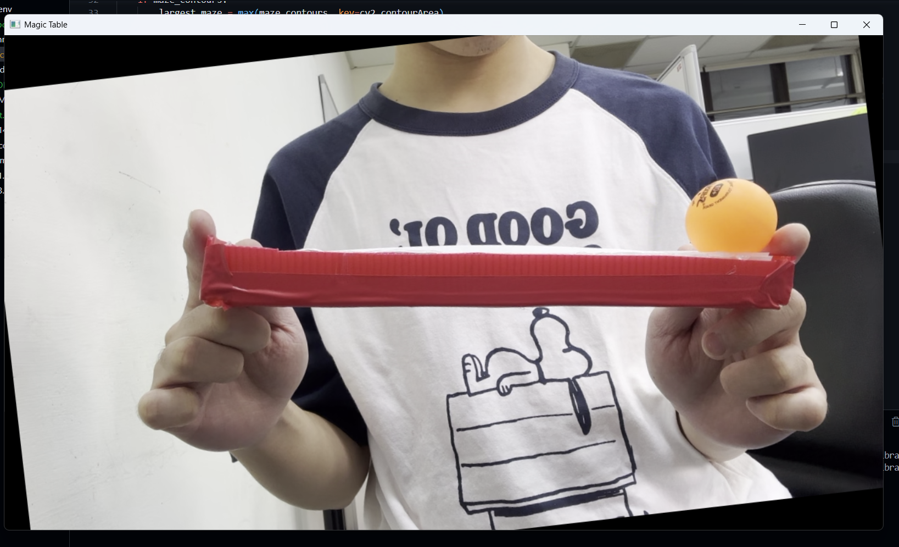
After rotating the frame, there will be noisy borders introduced by the rotation roi = stabilized_frame[90:frame_height-90, 130:frame_width-100], so we apply this frame cropping to hide it, and also to make it focusing on my box and ball.

- Evaluation & Result
cv2.minAreaRect() is the way we collect the angle after detecting the box, but the challenge actually is here: minAreaRect can represent the same physical rotated rectangle in two different ways (width/height swapped), which causes the returned angle to jump by ±90°.
https://docs.opencv.org/4.x/d3/dc0/group__imgproc__shape.html#ga3d476a3417130ae5154aea421ca7 the official website here mentioned that:
The function calculates and returns the minimum-area bounding rectangle (possibly rotated) for a specified point set. The angle of rotation represents the angle between the line connecting the starting and ending points (based on the clockwise order with greatest index for the corner with greatest y) and the horizontal axis. This angle always falls between [-90, 0] because, if the object rotates more than a rect angle, the next edge is used to measure the angle. The starting and ending points change as the object rotates. Developer should keep in mind that the returned RotatedRect can contain negative indices when data is close to the containing Mat element boundary.
Sadly, I spent one week with this problem before I found this article, and before I realized the solution was simple. if wm < hm: maze_angle += 90 I only need to make the angle refer to the same side and The if maze_angle > 170: maze_angle -= 180 is a manual wrap to avoid the ±180°/0° flip.

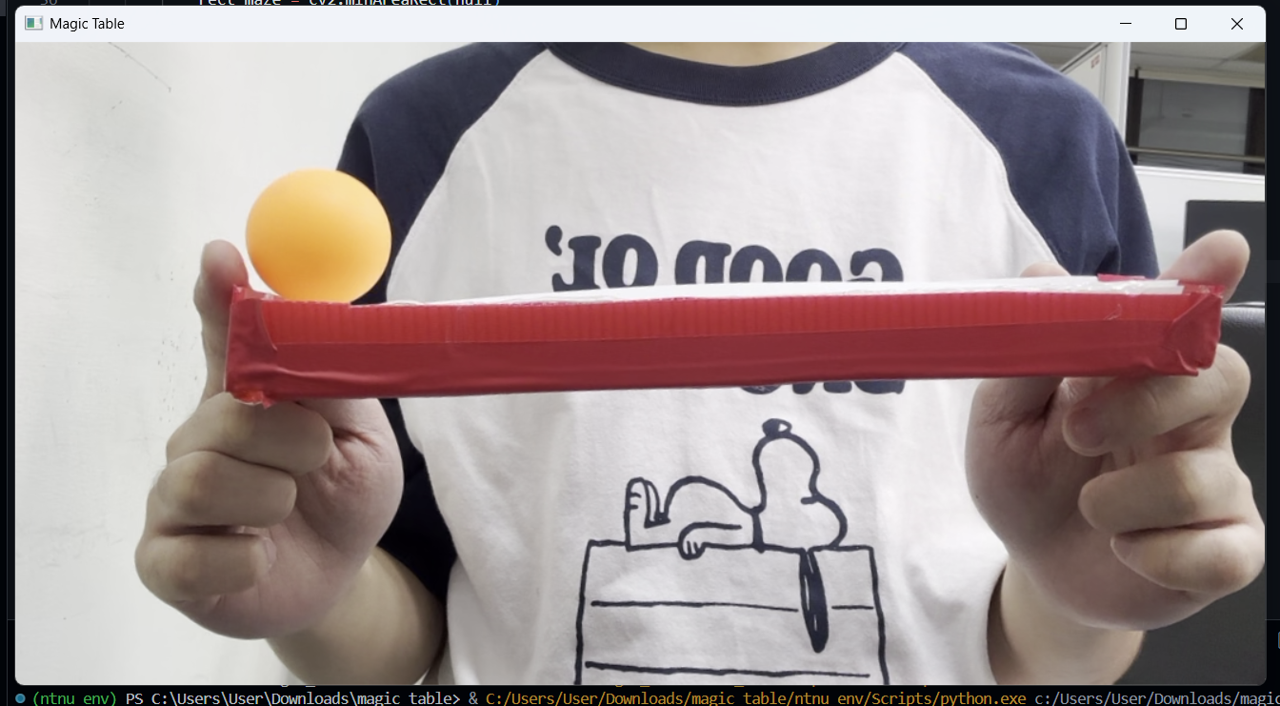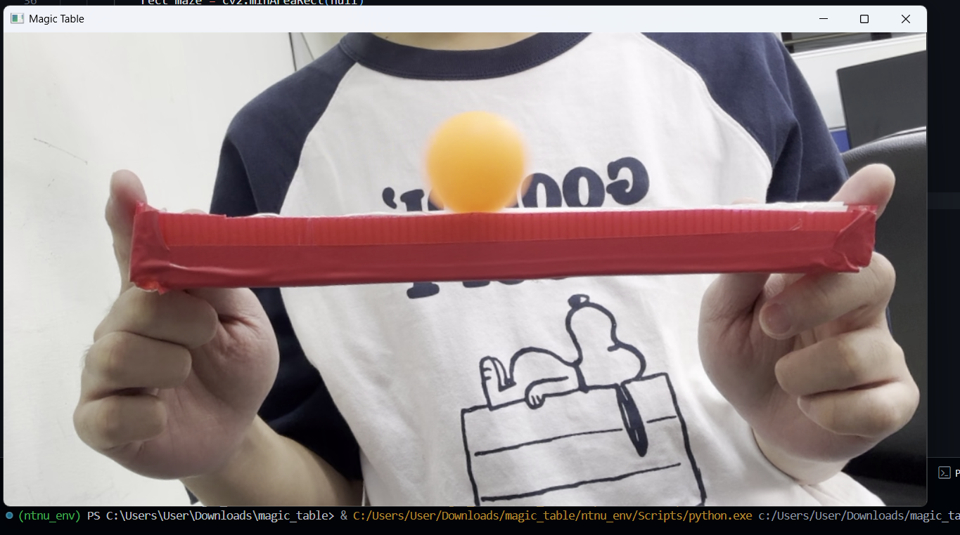

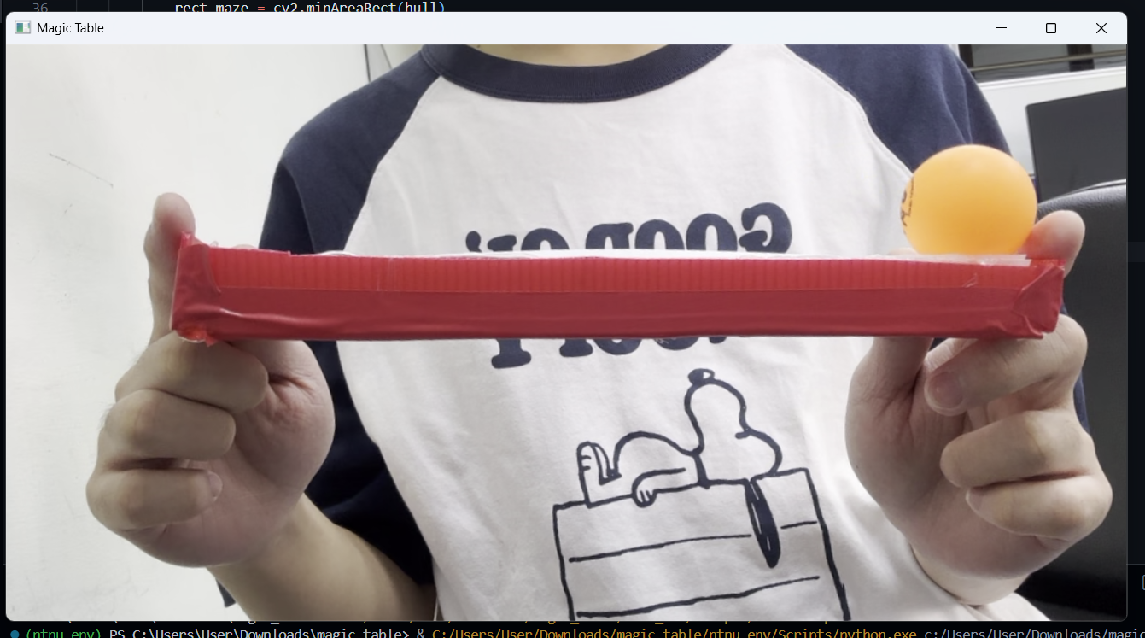

For me, this assignment was very hard, so I don’t expect too much. I thought I wouldn’t be able to do this, especially if I have to fulfill this statement by Professor Jacky Baltes, “You should have a total of four different systems”. Unfortunately, I’m unable to fulfill this, and I think I would have more time to study if I could utilize something like Edge Detection or Feature Point. So it was beyond my expectations, and I was surprised that I could still finish one requirement.

